**Article ID:** [4202] How to add salt to my dishwasher.

**Article name:** How to add salt to my dishwasher

**Topic location:** Dishwasher / Cleaning & Maintenance

**RFC:**

**Metadata:** filling

**Related articles:**

**Related questions:**

PNC

DIY

Safety

Link

Email

Book Engineer

Multimedia

Brand

**Article content:**

**WSS**

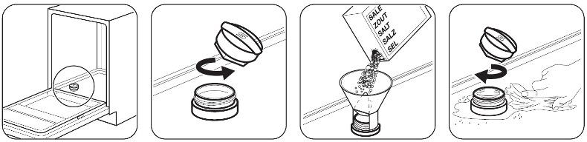

http://services.electrolux-medialibrary.com/bild.php?src=ehppdb-pictures/G/B/JPEG/PSGBDL140G002009.jpg

**Caution!** Water and salt can come out from the salt container when you fill it.

Risk of corrosion. To prevent corrosion, after filling the salt container, start a prewash programme.

Put 1 litre of water in the salt container (only for first use).

Only use salt, rinse aid and detergent for dishwashers. Other products can cause damage to your appliance.

Please refer to your User Manual for further assistance.